**Curriculum Vitae**

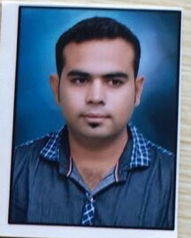**Mr. Deepak G. Kruplani**

**Personal Details**

Cell No: 7020936464

Email: deepak.kruplani@gmail.com

Address: Gurunank Nagar, Main Road, Karanja.

**Objective**

Skilled sales executive, adept at building immediate rapport with clients, determining needs and closing sales. Proficient negotiator and customer service expert. Outgoing and resourceful with superior work ethic and communication abilities. Innovative and successful in mining new sales territories and establishing business alliance.

**Education**

Exam: B.A

Session: 2014

Institution: Mumbai Hindi Vidyapith

Exam: M.A (appearing)

Session: 2019

Institution: Mumbai Hindi Vidyapith

**Computer Skill**

* Office Skill (MS Word, MS Excel, MS Access, MS Power Point, MS Outlook)
* Internet: Blogging, Browsing and E mail literacy
* Software Troubleshooting

**Highlights**

* Extensive Phone Knowledge
* Plan Optimization
* Familiar with range of accessories
* Maintain large customer range
* Confident and reliable

**Professional Experience**

Adarsh Cellcom, Karanja

* As an office co-ordinator for 2 years
* As a sales executive for a year

Vodafone India Ltd. (2010-2014)

* As a store Incharge for 4 years

**Language Proficiency**

Good command over English, Hindi, Marathi and Sindhi.